**ENGR 377: MANUFACTURING PROCESSES**

**2021 Winter Term I**

**Lab Project Report**

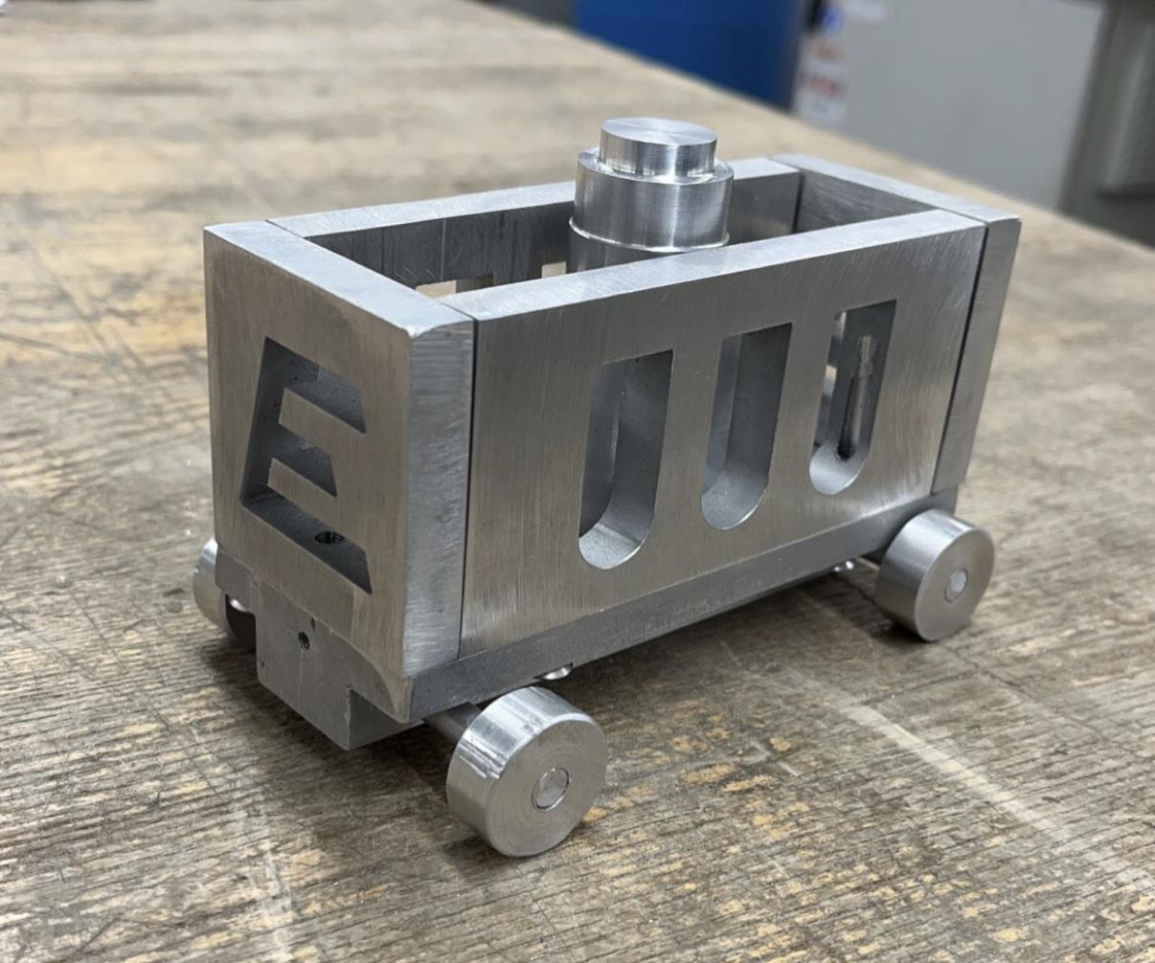

**Lab Section :L1H**

**Group Number : H1**

Prepared by (Fill in the following table):

| **Student No.** | **Name** | **Percentage contribution** | **Signature** |
| --- | --- | --- | --- |
| 65683799 | Agamjot Aneja | 50 | AA |
| 54392436 | Emily Bodenmann | 50 | EB |
|  |  |  |  |
|  |  |  |  |

School of Engineering | Okanagan Campus

The University of British Columbia

Date of Submission: December 6, 2021

# Executive Summary

As an engineer, it is important to get hands-on experience with the processes involved in machining products. In this lab, we learned how design translates to a finished product with the choice of creating a clamp or a train cart. Our group chose the train cart. We got to learn how to safely and properly use the mill, drill press, lathe, sander, bandsaw, and various hand tools. We learned the configuration and settings for each machine depending on our part and what result we were looking for. Our group ran into some challenges along the way but they were all learning experiences. This project overall was important because as future engineers, we now will make more considerations when designing projects. We will have a deeper understanding of what products are actually feasible and the best way of producing them.

# 

# 

# 

# 

# 

# Table of Contents

**Executive Summary** **2**

**Table of Contents** **3**

**Introduction** **4**

**Manufacturing Procedures** **5**

**Manufacturing Challenges** **6**

**Summary & Conclusions** **7**

**Appendix** **7**

# Introduction

Our group brought a train cart from a concept to a finished product and experienced the design process. By making the train we fulfilled all of the objectives of this lab. We learned about the manufacturing process in lectures and then got hands-on experience in this lab. The train cart required a mill, drill press, lathe, sander, bandsaw, and hand tools. We learned how to safely set up and operate each machine after deciding on the settings and configurations. Each tool was carefully selected to carry out the desired operation. We had to carefully interpret our drawings to set up the coordinates of the cut on our part. From the design, we had to decide what machining operation would get us the desired result.

We wanted to design a simple project and focus on fully experiencing the machines in the machine shop. The main components of our train cart were a T-shaped base with four wheels, four walls, and a chimney. The walls required the water jet to make the arched window cut and the letter “E” representing engineering. This was all planned using SolidWorks and printed out as drawings. In machining the parts, we learned that the water jet only makes through-cuts. The base was milled to shape and then we drilled holes into it for the axels. The wheels were cut on the bandsaw from a rod and then shaped to the desired diameter with holes which we press-fit onto the axels. Our chimney was turned as well to practice making more diameters. In the base and walls, we drilled and tapped holes so that we could screw together the train box. So overall, we got to practice milling, drilling, turning, and tapping operations and learn the setup and parts that go with each process.

At the beginning of the project, the biggest general challenge we anticipated was time. We had a given amount of time to come up with a realistic design and drawings before the first lab and then after that, we had a set amount of labs to complete the train in. We did not want to rush because that is when unsafe practices and machining errors happen, which delays the project. We completed the lab in time with the help of the makeup lab. At the beginning of the course, we anticipated that challenges could arise in that Emily had never been around any of the equipment before but with the help of Agamjot and the TAs everything worked out. Unanticipated challenges arose with our initial design which will be described later in this report.

# Manufacturing Procedures

The components making up our train included:

* T-shaped base
* E print walls x2
* Window cut walls x2
* Axels x2
* Wheels x4
* Chimney
* Screws x7

We used the mill, drill press, lathe, sander, bandsaw, and hand tools to create our train. The manufacturing process is summarized below: 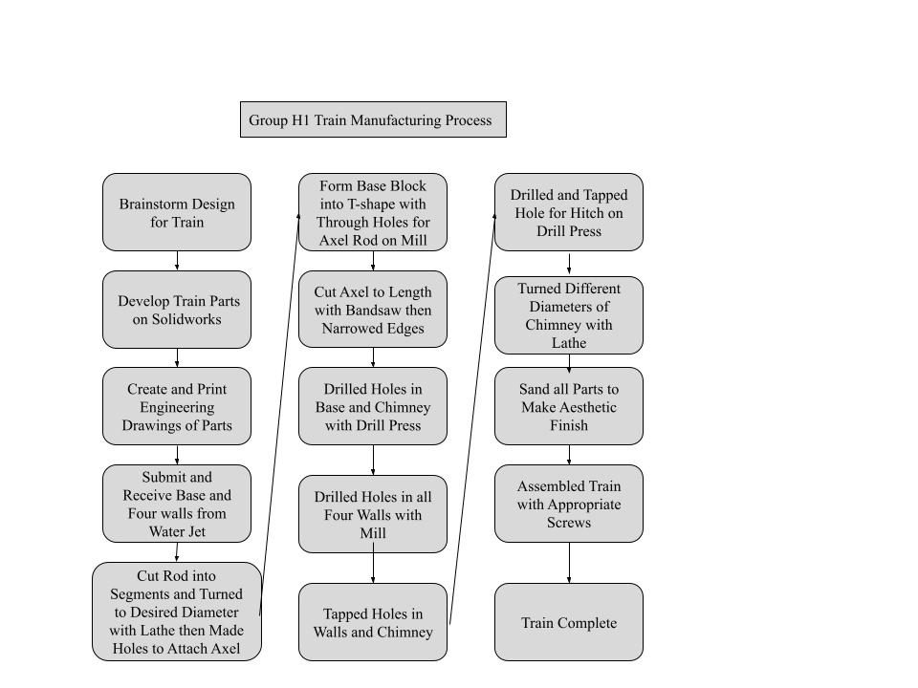



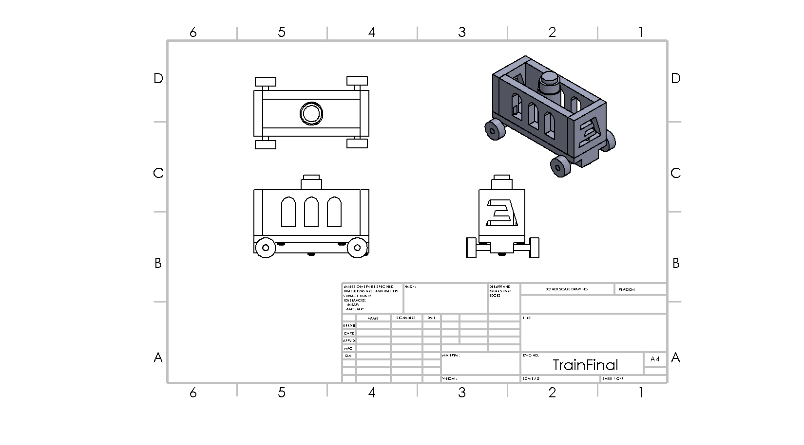

The initial drawings that we planned out in September did not have everything we needed for our final product and were updated along the way. The initial and final drawings can be seen in the appendix.

**Base:** The base was first designed in SolidWorks and then waterjetted as just a rectangular cube of aluminum. The base was then milled to its T-shaped bottom. Once the T was formed, the holes for the screws were also drilled using the mill as it reduced machine changing time, making the process more efficient.

**Walls:** The walls were designed in SolidWorks and then waterjetted as well. The walls required precision cutting as they had intricate designs therefore the waterjett was the best choice available as it was precise and time saving. The walls were then taken to the mill for holes and threading. These jobs were done simultaneously with all four walls together to save time in changing parts.

**Wheels:** We were given an aluminum rod which we cut to size. The rod was then placed on the lathe and using the cut-tool we were able to efficiently size all wheels to the same size all at once. Using the parting tool we were able to cut off the four wheels with accurate width, all within the lathe. The lathe was also used to drill a hole in the center of the wheels for the axle. The lathe was the perfect machine for this job as we were able to get all four wheels at the same time while being precise in our machining, hence saving time and being very efficient.

**Chimney:** The lathe was chosen to produce the chimney as it proved to be precise and efficient when changing diameters of a cylindrical object when it was used with the wheels. The hole for the screw was also drilled using the lathe as it keeps the object centered at all times.

**Axle:** The axle was first cut and then using the sanding machine we were able to file it down to desired dimensions. The sander was used as it files the part quickly therefore making the job less time consuming. The TA then used the lathe to narrow the axle so the wheels could be press fitted.

Collectively, all groupmates brainstormed and discussed what we wanted the train to look like. Following this, Agamjot made the part designs on SolidWorks. Emily later drafted engineering drawings that Agamjot updated and polished throughout the course of the project. Each group member had an opportunity at every machine process so that we could all learn and get the most out of this project.

# Manufacturing Challenges

We ran into some unexpected challenges in this project. Our initial drawings from September did not include everything. The 1'' thick aluminum plate mentioned in the project specs document was unavailable so all of our initial dimensions had to be adjusted accordingly during the first lab. Our initial drawings did not include the holes or taps. This was enough to work off of for a couple of labs but the drawings had to later be updated. For this reason, we drilled the holes into our base and walls before accounting for the hitch. The hitch hole ended up intercepting the screw hole in our base and we had to make a new attachment location for the wall. Later, when we went to thread the axel through the base, the parts did not fit together. We overcame this challenge by making the holes in the base larger.

In addition, we did not get the expected result when we drilled the walls on the mill. The space between the drilled hole and window was too close and intercepted. This would have been avoided if we had engineering drawings sooner but nothing could not be done after the fact.

If we did this project again, we would have a group of 4. Then we would completely design our train cart to meet all of the speculations and make an assembly before the first lab. This would make more efficient use of our time during our labs

because all of our decisions would already be made and we would have all of the information we need. The School of Engineering was very supportive in enabling our activities in the machine shop and we do not have any suggestions for improvement.

# Summary & Conclusions

Through the project, we were able to gain valuable experience using SolidWorks to design a model and different machines to bring the model to life. We were able to get comfortable with multiple machining tools such as a lathe, mill, and drill press. Throughout the project we gained insight into how products are made as well as the patience and skills needed to create these. We started off with first designing our train model in SolidWorks, then over the course of five machine labs, using different tools we were able to create it using aluminum. During the machine labs, multiple changes were made to the design to overcome challenges such as materials out of stock and time constraints. Overall both team members were able to proficiently use different machine tools to build the model and we were able to finish the product in time.

# 

# 

# 

# Appendix A: Initial Shop Drawings

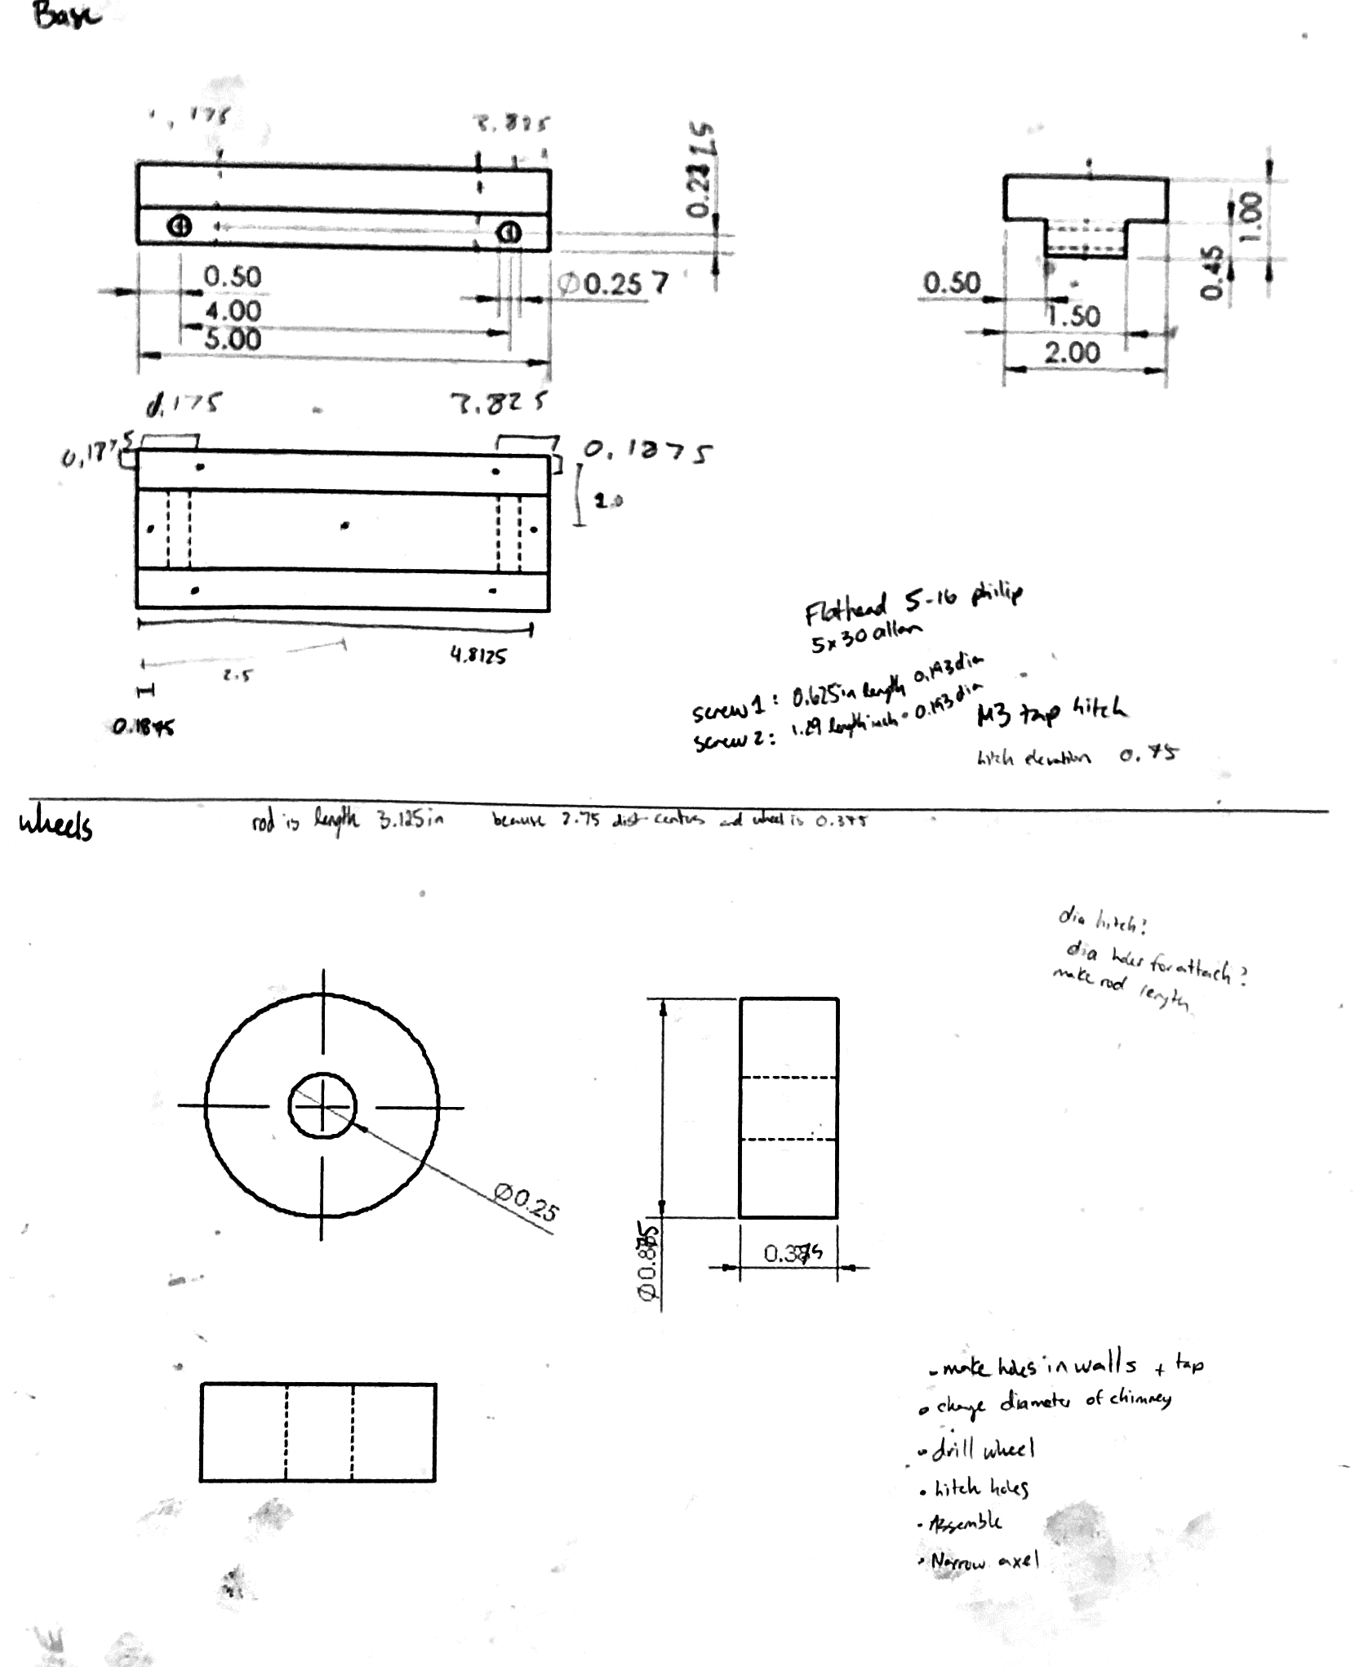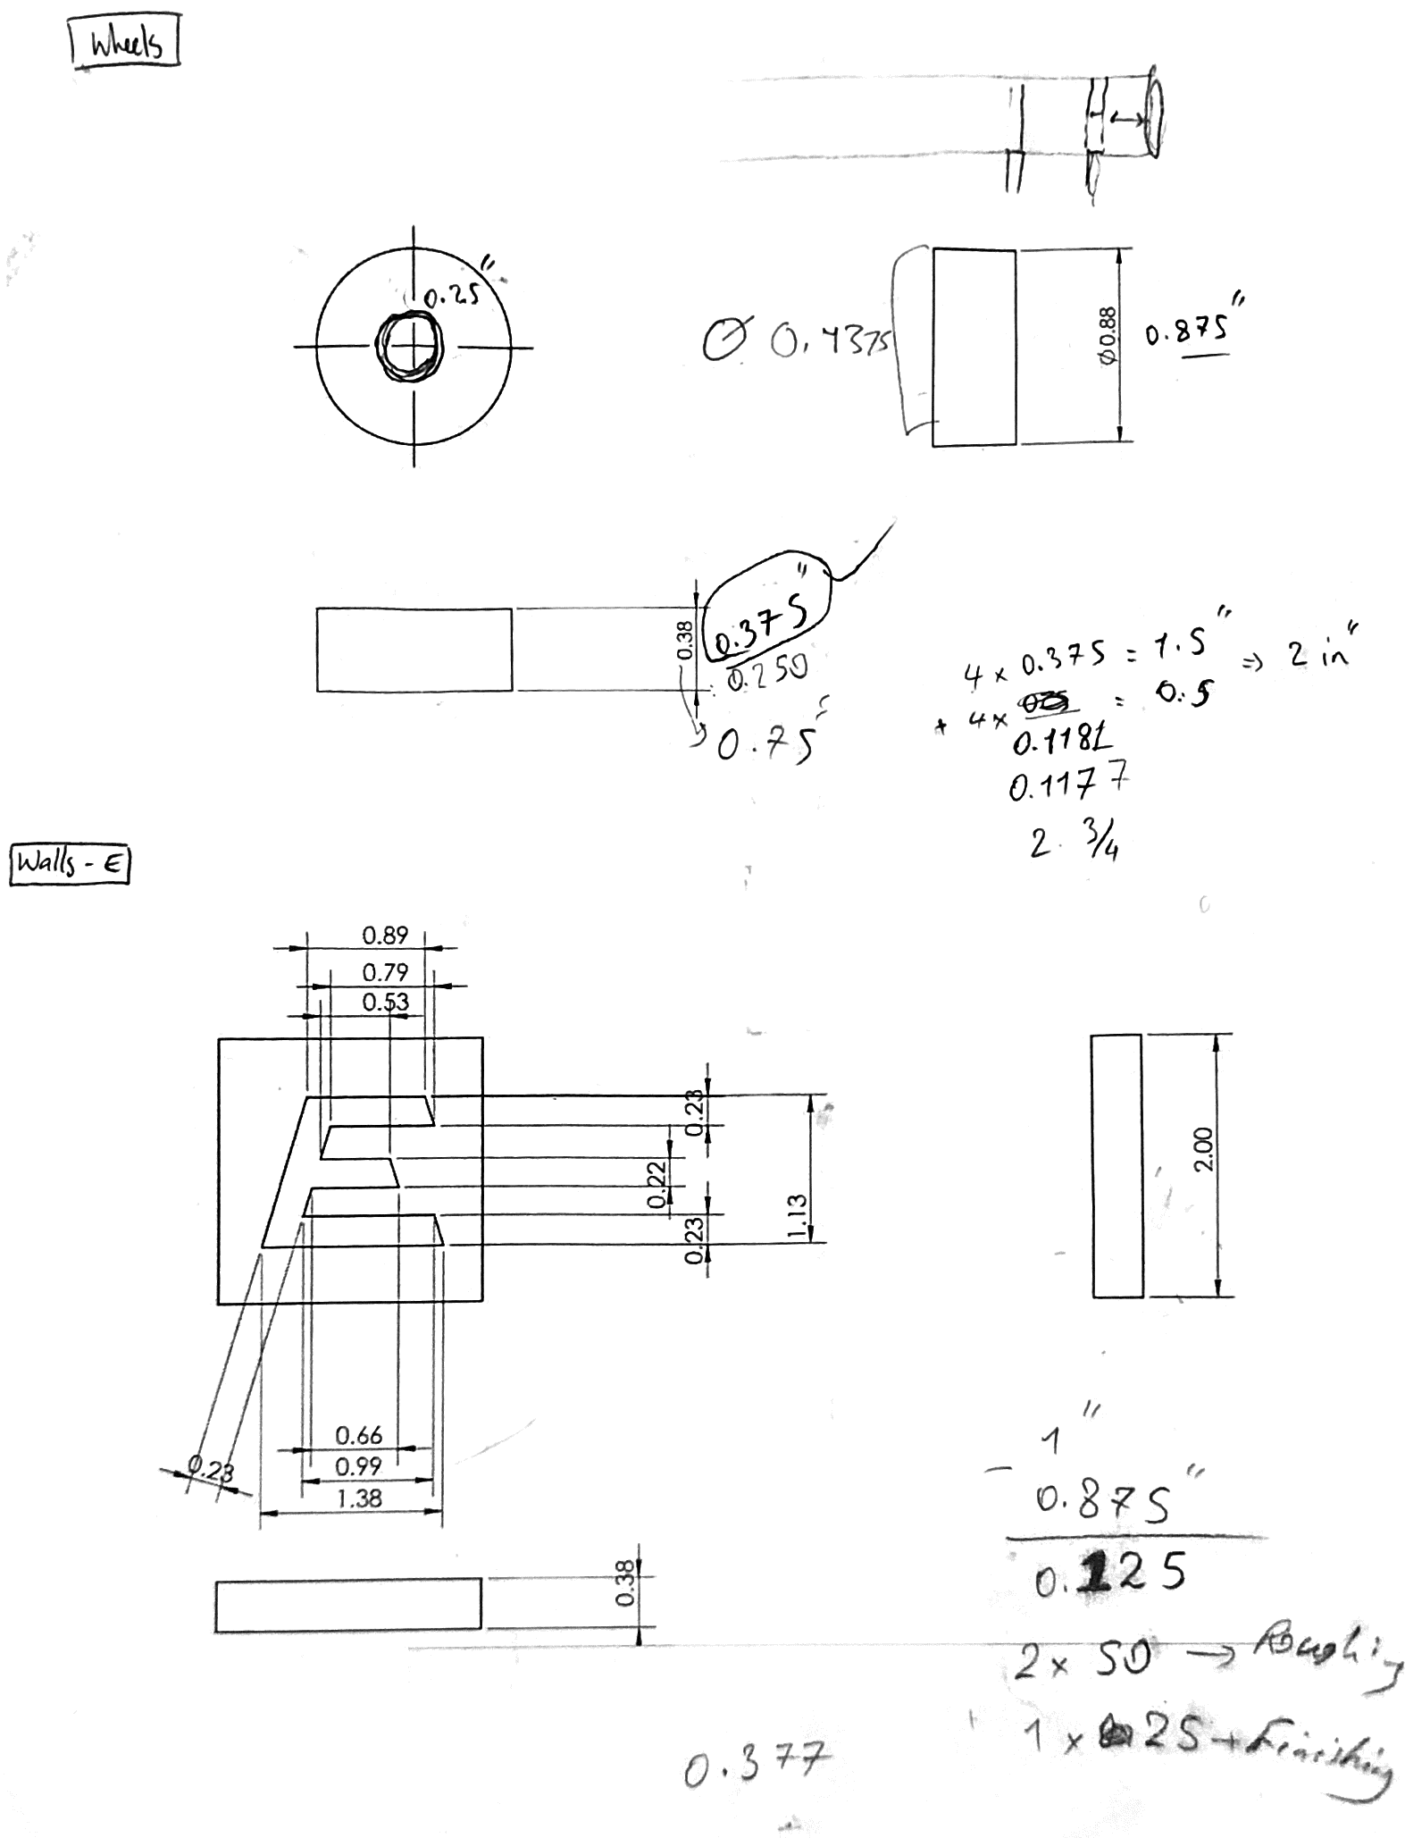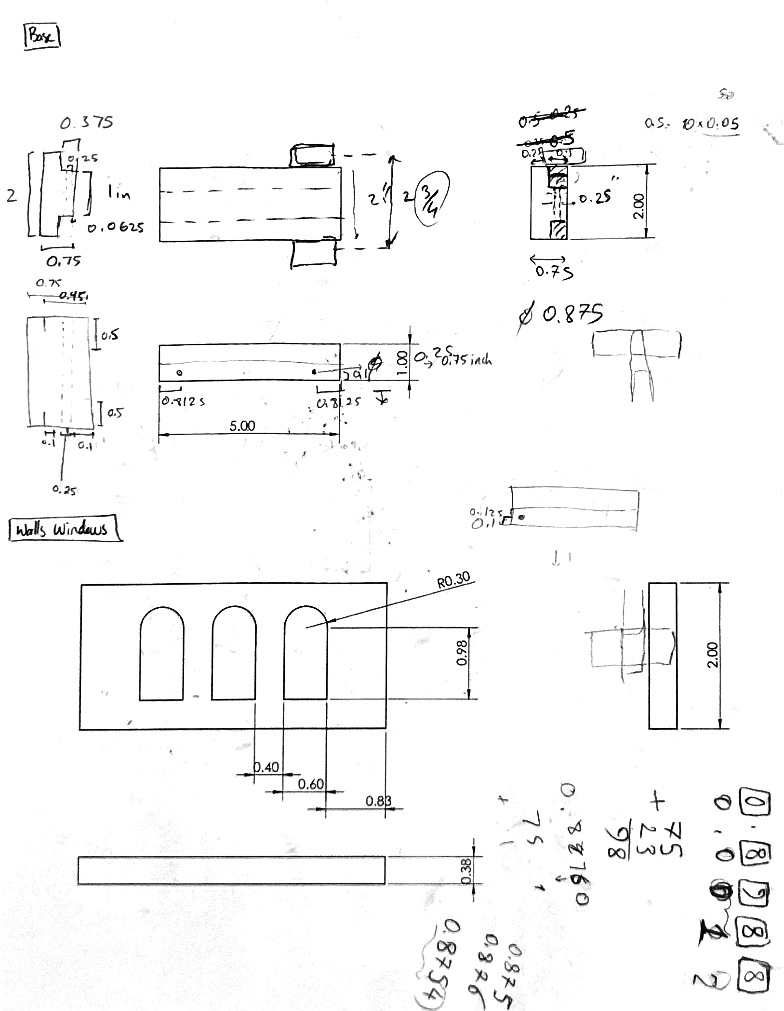

# Appendix B: Final Shop Drawings

